**CHEER**

1-2-3-4

Panthers, yell it out

Spell our letters, loud and proud

Yell, WHS, WHS

Panthers, on your feet

Yell our colors and repeat

Yell, Blue and White, Blue and White

Panthers for the win

Put it together and yell again

WHS, Blue and White

WHS, Blue and White

CHEER VIDEO

Go on you tube: it’s the AHS Tryout Cheer 2021 - https://youtu.be/PwwbJ1X9ZTc

[AHS Tryout Cheer 2021](https://youtu.be/PwwbJ1X9ZTc)

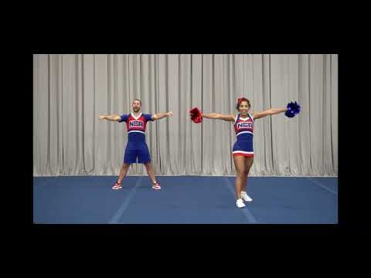

**DANCE**

Go on you tube and see link below:

[2017 Cheerleading Tryout Material Day 2](https://youtu.be/qE5000shS4U)

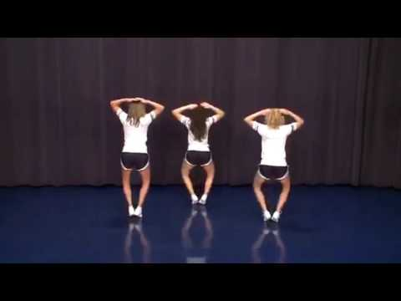

Be Mindful of Caps and lower case and numbers, below are zeros not Os.

https://youtu.be/qE5000shS4U